**Student Health Services**

Ms. Fay Lee, Health Aide

808-233-5727, ext. 228

King’s Health room provides students with basic health care and first aid. Students may come to the health room before school, recess, lunch and during class time (with a teacher note). Our health aide tends to their needs and contacts parents to inform them of the health situation.

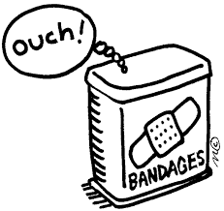Parents are advised to keep up with their child’s health care needs through regular check-ups with their own child’s doctors (including vision and dental). Provide plenty of rest, healthy eating and daily exercise to maintain good health. In the event of illness, please keep your child home when they have a fever, are contagious and/or are too ill for the rigors of the school day. The health room cannot keep a sick child in their supervision for the whole school day.

Please inform the health aide of any updates to your child’s health, e.g. allergies, medications or other health conditions. Contact information on your child’s emergency card should also be kept up-to-date. If students need to take medications during the school day, please contact the health aide.

**IMPORTANT NOTE REGARDING SERIOUS HEAD INJURIES**

**Parents:** Please inform your child’s teachers and our health aide of any serious head injuries immediately. Inform us of any medical restrictions.

A medical clearance will be needed for return to participation in any Physical Education classes.